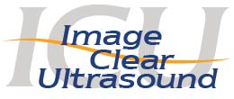

RDMS or Sonographer
We are looking for a part time RDMS or Sonographer to work on our Pregnancy Mobile Unit one to two days per week in Cuyahoga County.
Must possess an associate or bachelor’s degree with one to three years work experience or equivalent.
Needs to provide Christ -centered care to all clients/visitors and demonstrate strong teamwork skills.
If interested, please contact Michelle Grenig at mgrenig@icu-cuy.com.

RDMS or Sonographer
We are looking for a part time RDMS or Sonographer to work on our Pregnancy Mobile Unit one to two days per week in Cuyahoga County.
Must possess an associate or bachelor’s degree with one to three years work experience or equivalent.
Needs to provide Christ -centered care to all clients/visitors and demonstrate strong teamwork skills.
If interested, please contact Michelle Grenig at mgrenig@icu-cuy.com.

